***Assignment 1***

|  |  |  |  |
| --- | --- | --- | --- |
| **Answer the following questions below** |  |  |  |

For Q1 & Q2 you need to show your work

## Q1: Translate the following Bytes to Decimal and Hexadecimal



1. 00001001



1. 111111111



1. 11101110



1. 01010101



## Q2: Translate the following Decimal to Bytes (8-bit sequences)



1. 8



1. 3.15

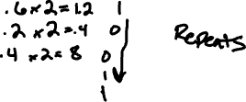

1. 134



1. -25

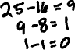

1. 226



1. 4



1. 10.185



## Q3: Write a C++ program to convert a binary number into hexadecimal.

Note: for this question you need to submit the source code and screen shot for the output

